

**[De]Globalisation and inflation**

Speech given by Mark Carney,

Governor of the Bank of England

2017 IMF Michel Camdessus Central Banking Lecture 18 September 2017

I am grateful to Clare Macallan and Iain de Weymarn for their assistance in preparing these remarks. I would also like to thank Will Abel, Fernando Eguren Martin, Rebecca Freeman, Alex Haberis, Simon Lloyd, Rana Sajedi, Andrej Sokol, Gregory Thwaites, Thomas Viegas, Matt Waldron and Gabija Zemaityte for the background research and analysis they conducted as well as Wayne Chapman, Chris Peacock and Lyndsey Pereira-Brereton for help with the presentation materials.

# Introduction

During his term as Managing Director, Michel Camdessus oversaw the second great wave of globalisation. The Berlin Wall fell, capital controls were liberalised, the euro was constructed, and China prepared to join the WTO. Product and financial markets became increasingly integrated, with trade growing at an annual rate of 10% and capital flows of 20%. The effective global labour force doubled, and more than a billion people were lifted out of poverty.

Central banks are now grappling with one consequence of such enormous achievements – the impact of globalisation on inflation.

All central banks must consider the cyclical relationship between global slack and domestic inflation; the degree to which secular forces from globalisation affect local inflation dynamics; and how global factors influence the stance of domestic monetary policy itself. And now some central banks may need to consider the implications for price stability if the process of globalisation were to slow or go into reverse.

These issues are particularly relevant to the Bank of England as the UK inflation outlook will be importantly influenced for some time by a process of de-integration under Brexit.

Today, I would like to draw on this example to illustrate how global factors influence domestic inflation dynamics and the ability of central banks to achieve price stability.

# Globalisation and Inflation

While the global Phillips Curve appears alive and well (Chart 1), globalisation has been accompanied by a weakening in the relationship between domestic slack and domestic inflation (Chart 2),1 and by a corresponding strengthening in the relationship between global forces and domestic prices.

1 As summarised by the slope coefficients in price and wage Phillips curves. The wage and price Phillips curves had already flattened during the 1970s and ‘80s, most likely linked – as Rogoff argued – to the institutional reforms made to monetary policy during that period. The finding of flattening Phillips curves has been widely documented. For example, Blanchard, O, Cerutti, E and Summers, L (2015), ‘Inflation and Activity – Two Explorations and their Monetary Policy Implications’, NBER Working Paper No. 21762, find that the median Phillips curve slope of 20 advanced and emerging economies fell by more than half between the mid-1970s and the mid-1990s, from around 1 to around 0.3.

# Chart 1: Global Price Phillips Curve?

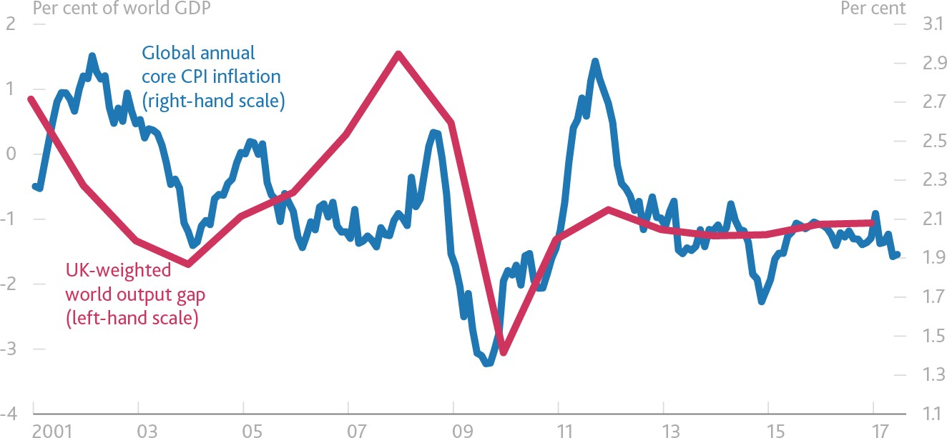

Notes: Average world output gap and global core CPI inflation (PPP-weighted). Sources: CEIC, IMF, ONS, Thomson Reuters Datastream and Bank calculations.

# Chart 2: Price and Wage Phillips curves have flattened throughout globalisation

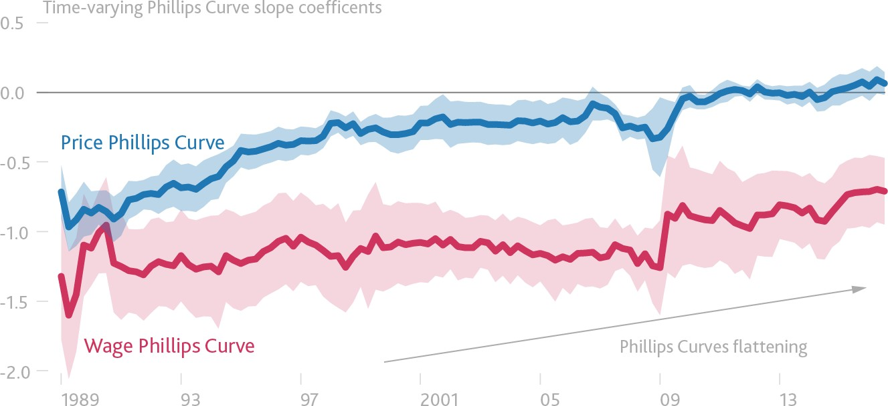

Source: BIS 87th Annual Report.

With correlations of headline CPI inflation rates as elevated today as during the first oil shock (Chart 3a), some contend that global forces have become dominant – a conviction reinforced by the ‘missing disinflations’ in the wake of the global financial crisis2,3 and by the current series of wage puzzles in

2 See, for example, Chapter 3 of the IMF’s WEO April 2013, ‘The dog that didn’t bark: has inflation been muzzled or was it just sleeping?’.

3 One explanation put forward for this, unrelated to globalisation, is that companies facing liquidity constraints maintained prices at higher levels than they would otherwise have done in order to preserve cash flows and remain in operation. See Gilchrist, S, Schoenle,

advanced economies.4 There are even suggestions that monetary policy frameworks should be overhauled

– potentially lowering the inflation target – in response globalisation’s growing impact.5

# Chart 3a: Superficially strong evidence of a global inflation cycle

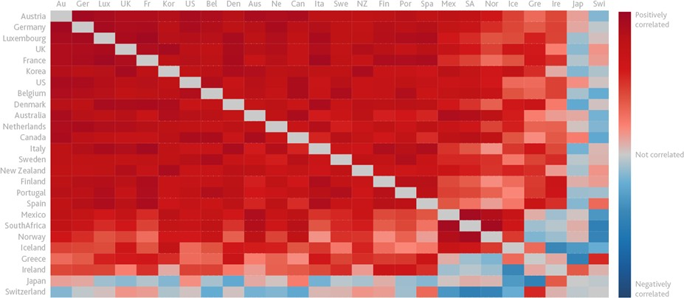

Notes: Correlations calculated using quarterly data on annual inflation rates. Sources: Thomson Reuters Datastream, National Sources and Bank calculations.

Some perspective is required.

Wage puzzles in advanced economies can be partly solved by recognising that post-crisis structural reforms have lowered natural rates of unemployment, by broadening measures of labour market slack to include involuntary underemployment, and by acknowledging that weak wages are one consequence of sustained poor productivity growth.6

More broadly, the recent high correlations of headline inflation rates have been driven by very large global shocks including the financial crisis and the commodity super cycle. Core inflation rates have actually exhibited little co-movement but rather have varied with (divergent) underlying economic conditions (Chart 3b).

R, Sim, J and Zakrajšek, E (2017), ‘Inflation dynamics during the financial crisis’, *American Economic Review*, Vol. 107, No. 3, pages 785-823. Consistent with this, analysis by Bank staff found that UK businesses with weaker balance sheets increased their margins by more at the height of the crisis than those with healthier balance sheets.

4 For example, as documented by the Bank for International Settlements (BIS) in their 87th Annual Report, 2017. See also Draghi, M

(2017), ‘Accompanying the economic recovery’, introductory speech at the ECB Forum on Central Banking 2017 and Danninger, S (2016) ‘What’s up with U.S. wage growth and job mobility’, *IMF Working Paper* 16/122.

5 For example, as suggested by Claude Borio, ‘How much do we really know about inflation?’, Presentation on the BIS 87th Annual Report, 25 June 2017.

6 See, for example, the boxes on pages 18-20 of the February 2017 *Inflation Report* and page 29 of the May 2014 *Inflation Report*. The solutions to these puzzles are also likely to involve some factors unrelated to globalisation. For example, one explanation put forward

for missing dis-inflation is that companies facing liquidity constraints maintained prices at higher levels than they would otherwise have done in order to preserve cash flows and remain in operation (see Gilchrist, S, Schoenle, R, Sim, J and Zakrajšek, E (2017), ibid.

Consistent with this, analysis by Bank staff found that UK businesses with weaker balance sheets increased their margins by more at the height of the crisis than those with healthier balance sheets).

# Chart 3b: Core information rates exhibited little co-movement post-crisis

See notes and sources to Chart 3a.

Central banks have (thus far) been able to maintain their monetary sovereignty, achieving their mandates by offsetting the secular disinflationary forces from global integration.

None of this, however, is to downplay current challenges of maintaining price stability in the face of global forces. The combination of the growing contestability of markets and prolonged synchronised weak demand may be restraining wage expectations. Moreover, technological changes, particularly those which could globalise markets for many services, may extend and deepen trend global disinflation. And, the global financial cycle could exacerbate the challenges of returning domestic inflation to target, particularly given the proximity of interest rates to the effective lower bound.

Charting a path for monetary policy in this environment thus requires a nuanced understanding of how globalisation both affects inflation and influences the stance of monetary policy. It is to these I will now turn.

***Global Influences on Domestic Inflation***

In a closed economy, inflationary pressures depend on developments in domestic costs, which in turn depend on domestic spare capacity, or the balance of domestic supply and demand.

Opening up the economy changes this relationship in three ways.

Most straightforwardly, external demand exerts pressure on domestic resource utilisation and therefore domestic inflation. The importance of this channel has steadily increased for most of the past half century (Chart 4).7

# Chart 4: External demand has steadily increased in importance

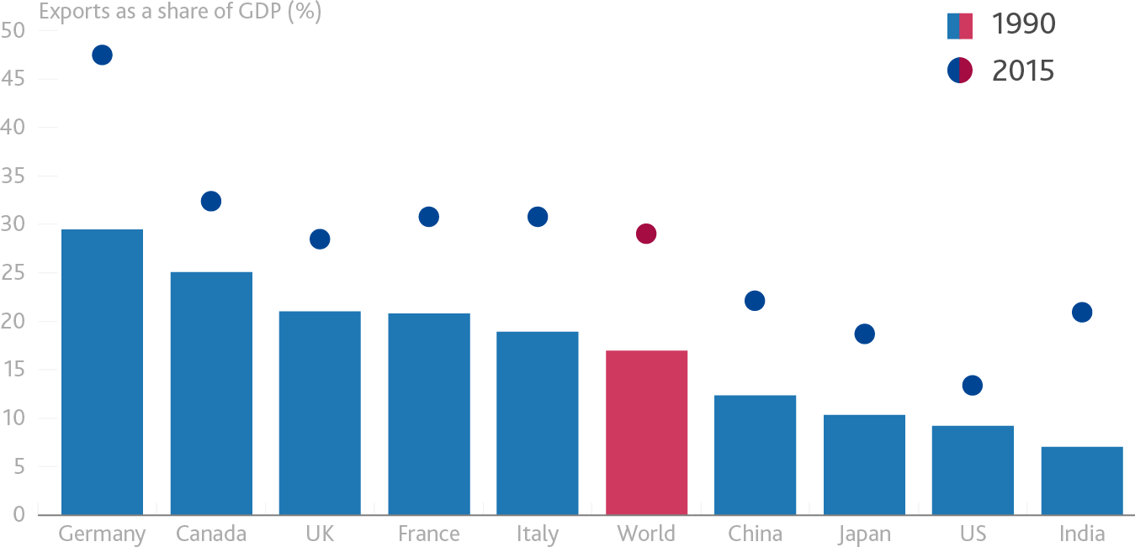

Sources: IMF and Bank calculations.

Next, in an open economy, prices of imports affect domestic inflation both directly – through the final goods and services bought by households – and indirectly – through the prices of imported intermediates used in the production of final goods and services in the consumption basket.

For years the direct effect has imparted a steady disinflationary bias. The integration of lower-cost producers into the global economy acts like an increase in potential supply for advanced economies, raising the level of spending that is consistent with inflation at target.8 Thus far, this disinflationary effect has mostly affected the prices of goods9 (Chart 5), as trade in goods has been liberalised to a much greater extent than services.10 Monetary policy makers in advanced economies have responded by accommodating relatively higher services price inflation in order to meet their inflation objectives. For example, in the UK core goods prices fell an average of 0.3% over the past two decades, services prices rose by an average of 3.4% and total CPI inflation was on average at target.11

7 The slowing of trade growth since the financial crisis largely reflects the rotation of global growth to countries with less import intensive demand, notably the US and EMEs, as well as the declining import intensity of final domestic demand in China as the composition of growth there rotates towards consumption and services.

8 This positive supply shock comes about because the availability of cheap imports improves advanced economies’ terms of trade – the price of exports relative to that of imports. For more detail on this channel, see ‘Globalisation and Inflation’, speech given by Charles

Bean at the LSE, 24 October 2006.

9 Abdih, Y, Balakrishnan, R and Shang, B (2016) ‘What is keeping US core inflation low?’, IMF Working Paper No. 16/124.

10 For example, barriers to services trade are estimated currently to be up to three times higher than those for goods trade. See ‘A fine balance’, speech by Mark Carney at the Mansion House, 20 June 2017.

11 Headline CPI inflation averaged 1.9% over this period.

# Chart 5: Sustained, cumulative relative price shock in goods accommodated through higher services price inflation

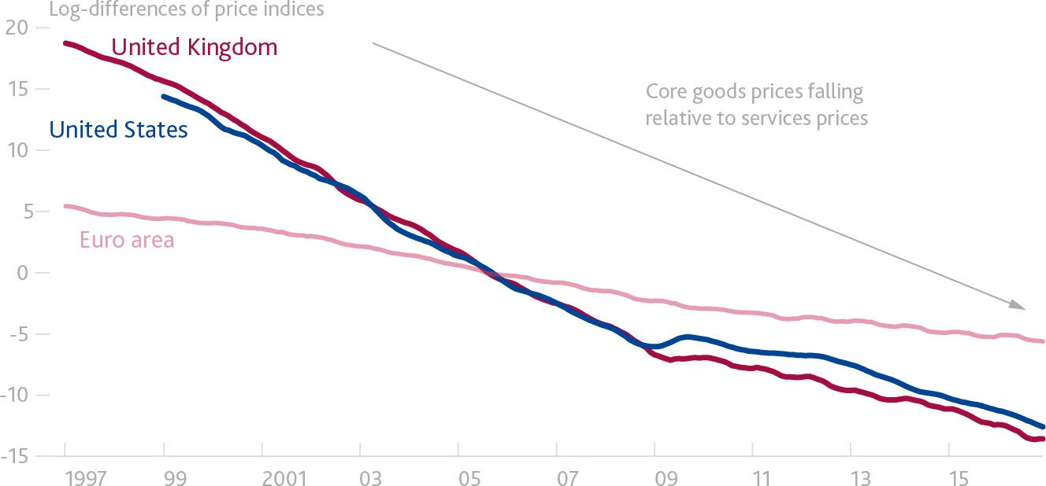

Notes: Six-month average of the log-difference between core goods prices (excludes food and energy) and services prices (series indexed; 2005 = 100). The US series uses PCE price indices.

Sources: Thomson Reuters Datastream, national sources and Bank calculation.

Globalisation has also led to a dramatic increase in the use of imported intermediates in domestic production. The ICT revolution has made a great unbundling of production into global value chains possible, and large wage differentials have made doing so profitable. Intermediate goods trade has represented 80% of the increase in total trade over the past two decades (Chart 6), driving up the value added of imports as a share from 10% of exports in 1990 to around 20% in 2015.12

12 See Auer, R, Borio, C and Filardo, A (2017), ‘The globalisation of inflation: the growing importance of global value chains’, *BIS Working Paper No.* 602.

# Chart 6: The development of global value chains has boosted trade in intermediates

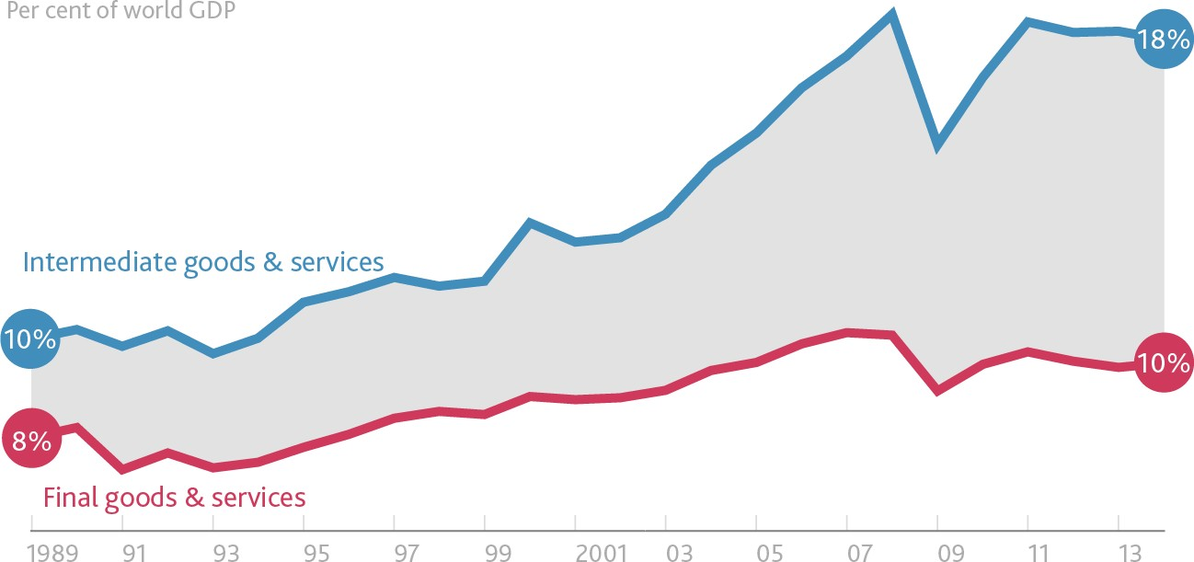

Notes: Imports and GDP are in current US dollars.

Sources: Johnson and Noguera (forthcoming), Powell (2016), World Input-Output Database (2016 release) and BIS.

This expansion in global value chains has led to greater synchronisation of producer price inflation across countries.13 And it has increased the sensitivity of domestic inflation to global inflationary pressures while reducing its responsiveness to changes in domestic slack.14 Research by the BIS indicates that a doubling in the share of imported intermediates in GDP causes the importance of global factors for domestic inflation to double as well.15 Consistent with that, research at the Bank of England indicates that each 1 percentage point increase in the import intensity of consumption reduces the sensitivity of inflation to domestic slack by 1 per cent, and that the strength of this effect varies with the ease with which producers can switch between imported intermediates and domestic alternatives.16

Monetary policy makers must take the effects of intermediate trade into account since, unlike commodity shocks, import price changes take time to work through supply chains into final goods prices and therefore affect inflation at the policy-relevant horizon.17

Labour markets provide a third channel through which globalisation affects domestic inflation. To be clear, globalisation is far from the only factor that has been affecting labour markets in recent decades – and

13 Auer, R, Levchenko, A and Sauré, P (2017), ‘International inflation spillovers through input linkages’, NBER Working Paper No. 23246. A shock that raises inflation by 1 percentage point in the rest of the world is found to raise domestic producer price inflation by (PPI) 0.2pp on average across the countries in the sample. The size of the effect varies significantly across countries, however; the UK is a little below average.

14 This depends, of course, on whether the good/service in the supply chain is sold on to become a final good/service in the same country or exported.

15 This is true both across countries and over time. See Auer, R, Borio, C and Filardo, A (2017), ibid.

16 See Cesa-Bianchi, A, Kindberg-Hanlon, G, Nelson, B and Thwaites, G, Bank of England, forthcoming. The speed at which changes in import prices are passed through to final goods is likely to differ across products. For example, for the UK, consumer food and

energy prices appear to respond more quickly than the prices of other goods and services. In part, that appears to be because margins at each point in the supply chain are tight. For food, it also partly reflects the fact some imported food is already the final consumption good – i.e. the supply chain is short.

17 See Goldberg, L and Campa, J (2010), ‘The sensitivity of the CPI to exchange rates: distribution margins, imported inputs, and trade exposure’, The Review of Economics and Statistics, Vol. 92, Issue 2, pages 392-407.

arguably, as work by the IMF and others has shown,18 technological progress has played a more significant role. Technology, not globalisation, is estimated to be the main reason why labour’s share of income has been falling across advanced economies.

But that does not mean global effects are absent.

The doubling of the effective global labour pool represents a huge, positive supply shock for the global economy. It has encouraged the shift of the production of goods and services that use lower-skilled labour intensively to countries with an abundance of lower-skilled workers – predominantly emerging market economies – while production of goods and services requiring more highly skilled labour has concentrated in countries with a greater share of higher skilled labour – predominantly advanced economies. The growing ability to split production components and tasks through global value chains has amplified this effect.19

Globalisation has also increased the contestability of labour markets, weakening the extent to which slack in domestic labour markets influences domestic inflationary pressures.20 That is, the increased ease with which activities can be off-shored or domestic vacancies filled by sourcing workers from abroad may have reduced the relative bargaining power and wage expectations of workers. While it is difficult to measure precisely, available evidence suggests that contestability effects could be significant.21 Greater openness appears to have reduced the sensitivity of wages to domestic labour market conditions22 and led to growth in domestic unit labour costs (ULCs) becoming more closely tied to global ULC growth.23

Overall, the greater global supply of labour has lowered the relative wages of lower-skilled workers in advanced economies. While this reduces inflationary pressures in the economy as a whole it has contributed to a long and painful period of adjustment for lower-skilled workers.24 The secular disinflationary effects from this steady integration of additional workers into the global labour market need to be taken into account in addition to the cyclical inflationary pressures from changes in labour market slack.

The various channels through which globalisation affects the relationship between domestic slack and inflation can be illustrated using the Phillips Curve (Figure 1).

18 See ‘Understanding the downward trend in labour income shares’, Chapter 3 of IMF WEO April 2017.

19 These effects – an example of factor price equalisation (Samuelson, 1948) – have been well documented for example by Autor, D, Dorn, D and Hanson, G (2015), ‘Untangling Trade and Technology: Evidence from Local Labour Markets’, The Economic Journal, Vol.

125, No. 584, pages 621-46. Bank staff analysis, using OECD data, suggests this mechanism has operated widely, with a range of countries seeing strong growth in non-tradeable employment compensate for declines in sectors most exposed to international labour substitution.

20 This channel also increases the role of the exchange rate in determining inflationary pressures, since it will affect the home-currency value of the wage workers from abroad would earn by relocating and therefore their willingness to move.

21 For example, for the US, Blinder, A (2009) ‘How many US jobs might be offshorable?’ *World Economics* Volume 10 Issue 2, estimates

that the potential to offshore service sectors jobs may have lowered wages by up to 14%. Arseneau, D and Leduc, S (2011), ‘Threatening to offshore in a search model of the labor market’ build contestability into a two-country model and find it can reduce wages by up to 5% in the source country.

22 Rotunno, L and Wood, A (2016), ‘Wage inequality and skill supplies in a globalised world’, *Aix-Marseille School of Economics Working Paper*.

23 BIS 87th Annual Report, ibid.

24 As noted above, technological changes have played a greater role in driving down the relative wages of less skilled workers.

# Figure 1: Effects of globalisation on the Phillips curve

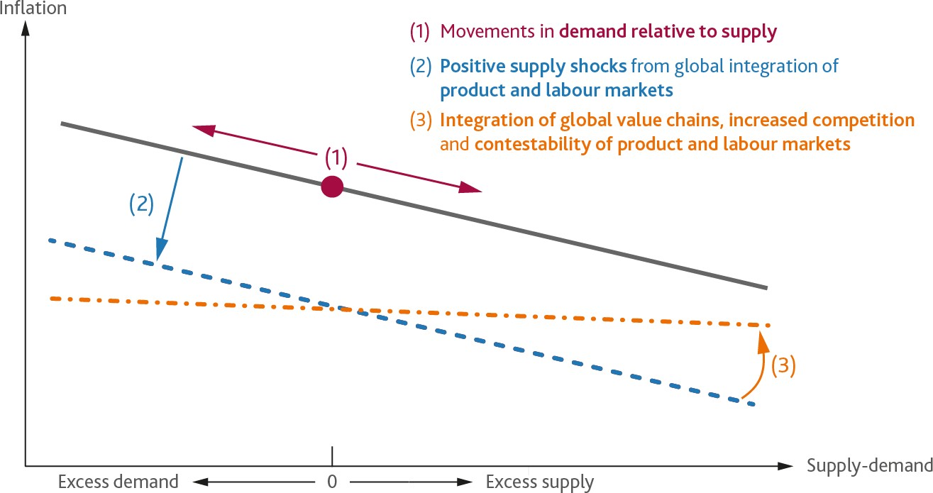

Changes in external demand will cause a shift along the Phillips Curve, as domestic companies adjust capacity utilisation in response (1).

The series of positive supply shocks from increased product and labour market integration cause parallel shifts down in the Phillips Curve (2). These downward shifts will persist as long as integration continues. This may take a while, not least because the advent of digital platforms may extend these processes to a much broader range of goods and services markets.25 The domestic economy needs to be run with tighter spare capacity to accommodate these disinflationary effects.

The increased competitive forces from globalisation (both actual and contestable) have also acted through product and labour markets to decrease the responsiveness of inflation to domestic slack, flattening the Phillips Curve slope (3).

Monetary policy must take all these effects into account and, on balance, run the domestic economy with tighter spare capacity in order to accommodate them.

# Global Influences on the Stance of Monetary Policy

Just as global factors affect the relationship between domestic slack and inflation, they influence the monetary policy setting needed to achieve the inflation target. In particular, global integration affects the transmission mechanism of domestic monetary policy, the degree of spillovers from foreign monetary policies, and the equilibrium rate of interest itself.

25 If and when global integration stops progressing, this shift down in the Phillips curve would reverse.

For the past thirty years, a number of profound forces in the world economy has pushed down on the level of world real interest rates by as much as 450 basis points (Charts 7 and 8).26 These forces include the lower relative price of capital (in part as a consequence of the de-materialising of investment), higher costs of financial intermediation (due to financial reforms), lower public investment and greater private deleveraging.27 Two other factors – demographics and the distribution of income – merit particular attention.28

# Chart 7: Global long run real interest rates have fallen over the past 30 years

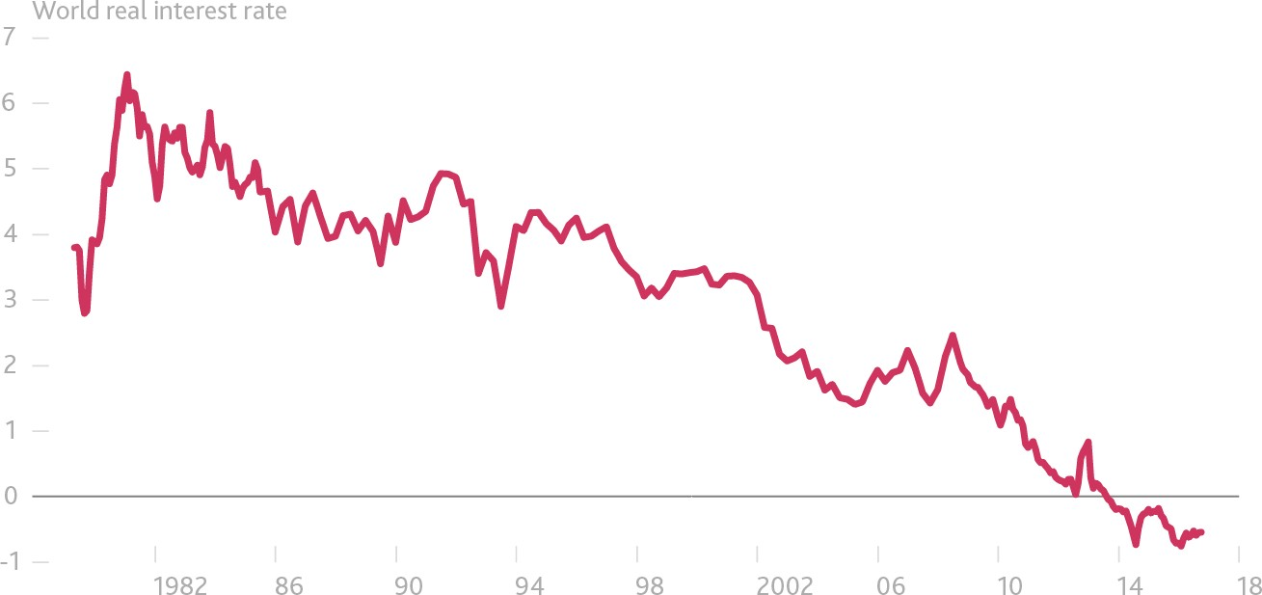

Source: Rachel, L and Smith, T (2015), ibid.

26 Rachel, L and Smith, T (2015), ‘Secular drivers of the global real interest rate’, Bank of England Working Paper No. 571.

27 It is sometimes claimed that the equilibrium real rate depends on the (expected) rate of growth, but this is an oversimplification. The

entire distribution of growth rates matters: not only the mean, but also the volatility, asymmetry and fatness of the tails. See ‘Real interest rates and risk’, speech by Gertjan Vlieghe at the Society of Business Economists’ Annual conference, 15 September 2017.

28 For a discussion of the wider implications of these forces, see ‘Debt, Demographics and the Distribution of Income: New challenges for monetary policy’, speech given by Gertjan Vlieghe at the London School of Economics, 18 January 2016.

# Chart 8: Secular drivers pushing down long-run equilibrium real interest rate

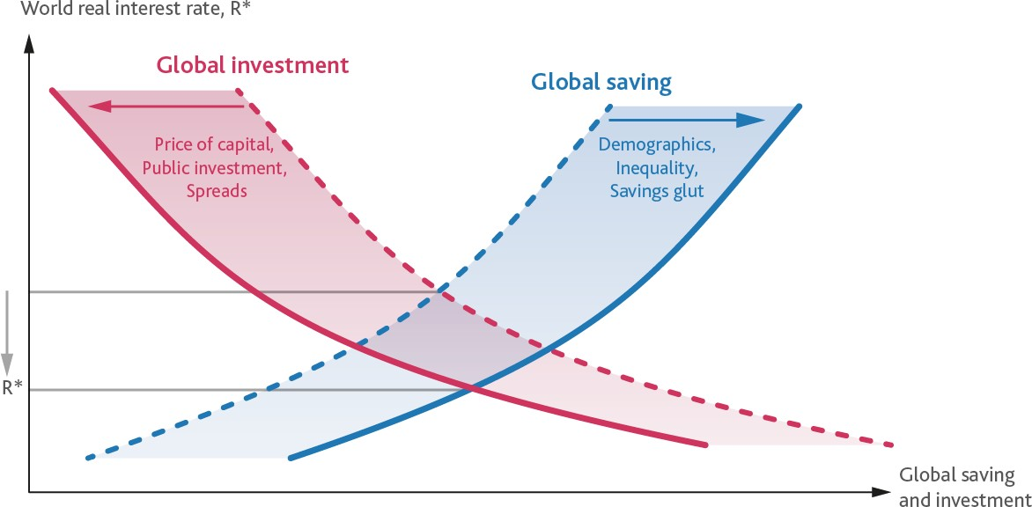

Bank research estimates that the increased retirement savings as a result of global population ageing and longer life expectancy have lowered the global real interest rate by around 140 basis points since 1990 and they could lead to a further 35 basis point fall by 2025.29 The crucial point is that these effects should persist after the demographic trends have stabilised because the stock, not the flow, of savings is what matters.30

By changing the distribution of income, the global integration of labour markets may also lower global R*. The changes in relative wages in advanced economies have shifted income towards skilled workers, who have a relatively higher propensity to save. Rising incomes in emerging market economies may be reinforcing that effect as saving rates are structurally higher in emerging market economies, reflecting a variety of factors including different social safety regimes.31

The high mobility of capital across borders means that returns to capital will move closely together across countries, with any marked divergences arbitraged.32

As a consequence, global factors are the main drivers of domestic long-run real rates at both high and low frequencies (Charts 9 and 10). For example, Bank of England analysis suggests that about 75% of the

29 Lisack, N, Sajedi, R and Thwaites, G, ‘Demographics and the real interest rate’, forthcoming.

30 Although retirees dis-save, they also tend to retain relatively high wealth during their retirement, so as the share of the population in retirement increases the stock of savings will remain elevated even as the flow of savings falls.

31 As Ben Bernanke noted, a ‘savings glut’ from emerging economies developed in the run-up to the crisis (see remarks on ‘The Global saving glut and the US current account deficit’, 10 March 2005). Global labour market integration could also have lowered the

equilibrium real interest rate because households in EMEs are relatively risk averse, and this has increased global risk aversion as wealth has shifted from AEs to EMEs; see Hall, R.E. (2016), ‘The role of the growth of risk-averse wealth in the decline of the safe real interest rate, NBER Working Paper No.22196.

32 Of course, various frictions to complete capital mobility – including home bias, borrowing constraints because securities are imperfect substitutes and incomplete risk sharing across countries – will yield some divergence.

movement in UK long-run equilibrium rates is driven by global factors (Chart 10).33 Estimates by economists at the Federal Reserve deliver similar results (Chart 11).34

# Chart 9: Close co-movement of long-run interest rates at high frequency…

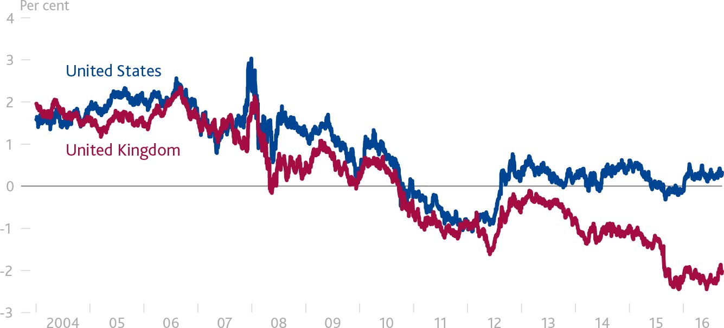

Notes: 10-year real bond yields derived from inflation swaps. Sources: Bloomberg and Bank calculations.

# Chart 10: …and at low frequency

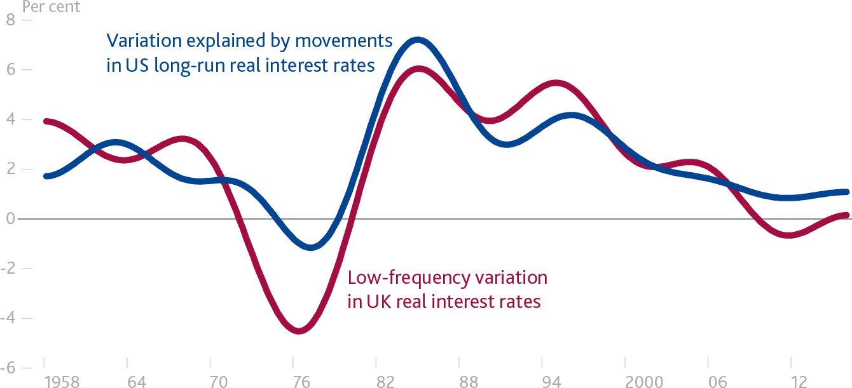

Notes: UK long-run equilibrium real interest rate and fitted values obtained from simple regression on US long-run equilibrium real interest rate.

Sources: Bloomberg and Bank calculations.

33 Applying the recently-developed technique for estimating low-frequency co-movement in Mueller, U and Watson, M (2015), ‘Low- frequency econometrics’, NBER Working Paper No. 21564,’using data since the 1950s.

34 Holston, K, Laubach, T and Williams, JC (2016), ‘Measuring the natural rate of interest: International trends and determinants’, Journal of International Economics, Vol. 108, Supplement 1, pages S59-S75.

# Chart 11: Majority of long-horizon variation in UK equilibrium rates explained by international factors

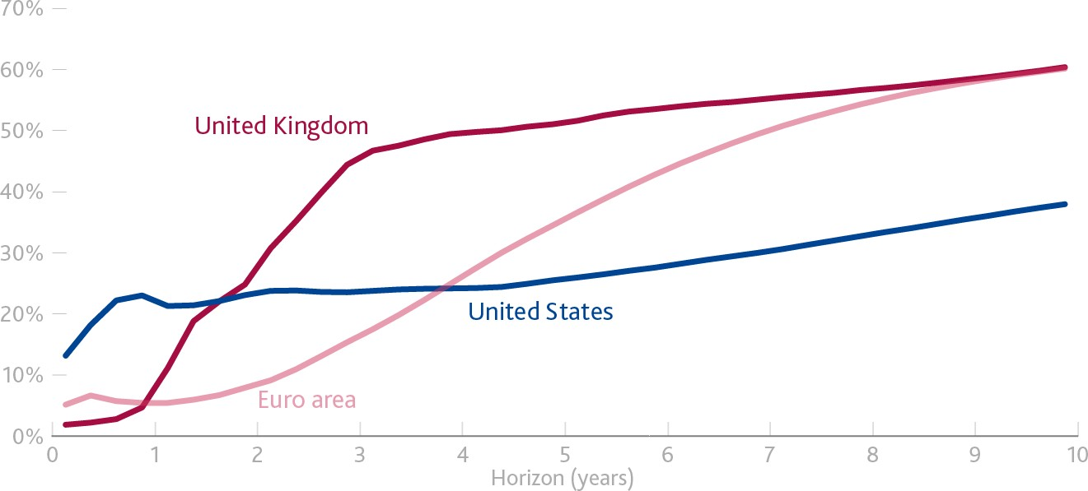

Notes: Forecast error variance decomposition from a vector error correction model, share not explained by domestic R*. Sources: Holston, K, Laubach, T and Williams, JC (2016), ibid.

Global factors also influence domestic financial conditions and therefore the *effective* stance relative to the shorter-term equilibrium rate of monetary policy, r*.

The presence of borrowers and lenders operating in multiple currencies and in multiple countries creates multiple channels through which developments in financial conditions can be transmitted across countries.35 For example, changes in sentiment and risk aversion can lead to international co-movement in term premia, affecting collateral valuations and so borrowing conditions.

Work by researchers at the Bank of England, building on analysis by the IMF,36 shows that a single global factor accounts for more than 40% of the variation in domestic financial conditions across advanced economies. For the UK, which hosts the world’s leading global financial centre, the relationship is much tighter, at 70%.

Highlighting the openness of the UK economy and financial system, a third of the business-cycle variation in the UK policy rate can be attributed to shocks that originate abroad.37

One important channel of global spillovers is of course monetary policy. In coming years, it is reasonable to expect global term premia to rise as net asset purchases could shift significantly from the situation during the past four years when all net issuance within the G4 was effectively absorbed (Table 1).

35 Hélène Rey has been a key proponent of the importance of such channels. See, for example, Miranda-Agrippino, S and Rey, H (2015), ‘World asset markets and the global financial crisis’, NBER Working Paper No. 21722.

36 IMF Global Financial Stability Report 2017, Chapter 3.

37 Cesa-Bianchi, A and Sokol, A ‘The international credit channel of US monetary policy and credit shocks’, forthcoming.

# Table 1: G4 net asset issuance still low in 2017

|  |  |  |  |  |  |  |  |  |  |  |
| --- | --- | --- | --- | --- | --- | --- | --- | --- | --- | --- |
| $bn | 2008 | 2009 | 2010 | 2011 | 2012 | 2013 | 2014 | 2015 | 2016 | 2017 |
| Asset purchases | -61 | 1756 | 451 | 670 | 642 | 1756 | 1254 | 1312 | 1799 | 1338 |
| Bond issuance | 2936 | 2664 | 3534 | 2486 | 2263 | 1753 | 1525 | 1093 | 1286 | 1527 |
| Net  issuance | 2997 | 908 | 3083 | 1816 | 1622 | -3 | 270 | -219 | -513 | 189 |

Notes: G4 here are the UK, EA, US and Japan. Bond issuance refers to annual changes in the stock of the general government debt. Agency debt is also included for the US. Asset purchases refer to total amount of bonds purchased by the central banks. Annual asset purchases are obtained by summing net monthly purchases over corresponding 12 months. Monthly flows are converted into US dollars by using an average monthly exchange rate. Sources: ECB, Bank of England, Federal Reserve, Bank of Japan, SIFMA, Thomson Reuters Datastream and Bank calculations.

The Fed’s widely trailed intention to reduce gradually its holdings of US Treasuries could ultimately have significant effects on financial conditions globally. Although the precise degree and timing of this effect are subject to considerable uncertainty, the direction is clear: reducing the stock of purchased assets should increase the term premium for US treasuries (due to both portfolio balance and signalling effects). Fed staff recently estimated that balance sheet normalisation could ultimately lead to a 75 basis point rise in the 10- year term premium.38 According to the July Primary Dealer Survey, the median expected rise in the 10-year US Treasury yield over the next two years due to a reduction in the balance sheet is around 30 bps (with an interquartile range of 20-50bps). Whatever happens, Bank analysis suggests that around two-thirds of changes in US term premia will spill over into the UK over time.39

# Should the Monetary Policy Framework be adjusted?

In summary, global demand has become more important for pressures on domestic capacity (i.e. movements along the Phillips Curve) and global integration along all dimensions – labour, final goods and services, and intermediates – acts as a series of positive supply shocks that impart sustained disinflationary pressures (i.e. shifting the Phillips Curve downwards and flattening it).

And just as global factors affect the relationship between domestic slack and inflation, they have made it more difficult for central banks to set policy in order to achieve their objectives. Major secular forces have lowered the equilibrium rate of interest, meaning that central banks have had to use unconventional tools in order to provide stimulus. At the same time, open and integrated markets have reduced central banks’ control over their domestic financial conditions.

In the wake of such disinflationary challenges some have argued that monetary policy frameworks should be overhauled. For example, Claudio Borio recently suggested that the secular disinflationary effects from continued global integration could dominate increased cyclical inflationary pressures from a smaller global

38 Bonis, B, Ihrig, J and Wei, M (2017). ‘The Effect of the Federal Reserve's Securities Holdings on Longer-term Interest Rates’ FEDS Notes. Washington: Board of Governors of the Federal Reserve System, 20 April 2017.

39 This analysis uses the IMF’s Flexible System of Global Models, a semi-structural model of the global economy that captures international trade and financial linkages.

output gap as the recovery progresses.40 In keeping with BIS traditions, Borio encourages central banks to lean into the wind, accepting lower inflation outcomes, for both macroprudential reasons and to accommodate the positive global supply shock.41

In my view, the bar for changing monetary policy frameworks should be very high. Consider the Bank of England. We have a wide range of macroprudential tools that allow monetary policy to be the last line of defence against financial stability risks. Our monetary policy remit from HM Government gives the MPC the necessary constrained discretion to respond flexibly to real shocks, including from globalisation, while maintaining the primacy of price stability. More generally, to the extent there is “good deflation” from globalisation, it exists in parallel with lingering risks of an old-style, Fisher debt deflation which could be very bad indeed.

I am also mindful that central banks have generally been able to achieve their objectives and that, with the strengthening and broadening global expansion, cyclical forces should ease constraints on central banks. In addition, as demand in a number of major economies rotates from consumption towards investment42 (Chart

12) and as fiscal policies become less contractionary,43 short-term equilibrium real interest rates should rise everywhere. This means that a static monetary policy stance becomes more expansionary all else equal.

# Chart 12: Strong capital goods orders point to demand rotating towards investment

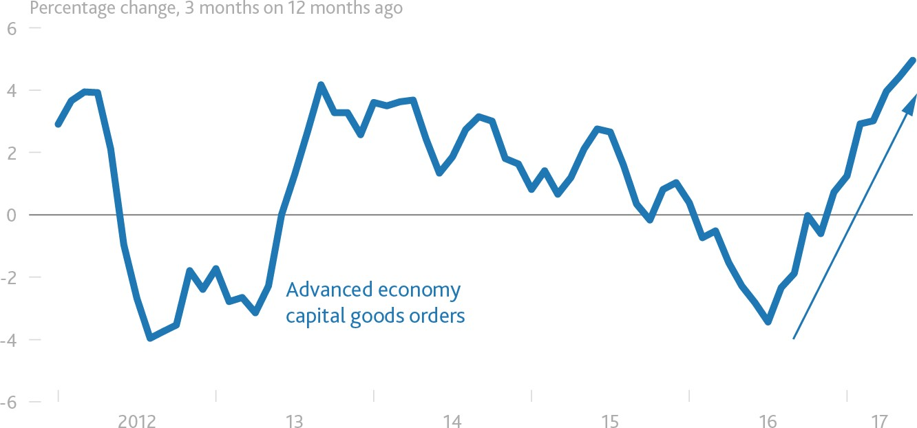

Sources: Sources: Thomson Reuters Datastream and Bank calculation.

40 Borio, Presentation on the BIS 87th Annual Report, ibid.

41 Some have argued that inflation targets should be raised. The claimed benefits from doing so may rely excessively on the relationship between the inflation target and inflation expectations in a deflationary environment and in proximity to the lower bound on

interest rates.

42 The contribution of investment to world GDP growth has picked up to 0.7pp in 2017 Q1 from an average of 0.3pp during 2016 / Investment has contributed 70% to the pickup in world GDP growth between 2016 Q1-Q3 and 2016 Q4-2017 Q2.

43 The global fiscal structural balance narrowed by 2.5% of world GDP between 2010 and 2014 but has widened by around 0.5% since then.

That said, I would caution that the persistence of major secular factors pushing down on the long-run global equilibrium real rates still means that policy rates can be expected only to rise a limited extent at what can be expected to be a gradual pace, settling at levels significantly below those seen pre-crisis.

# Brexit: De-Globalisation and Inflation

The UK is a highly open economy. Its trade, particularly with the EU, is an important determinant of domestic inflationary pressures. Pass through of imported inflation (including from persistent exchange rate changes) is significant and can materially influence inflation over the policy horizon. And UK financial conditions are influenced by foreign developments to a greater extent than in other major economies.

The UK has begun the process of redefining its relationship with its largest trade and investment partner. To be clear, the intention is not to turn inwards but rather to increase openness over time. In particular, the UK government’s objective is a “comprehensive, bold and ambitious free trade agreement with the European Union.” Leaving the EU is intended to enhance the UK’s ability to strike trade and investment agreements with a wide range of countries beyond those covered by virtue of its membership of the EU.

But Brexit is an example of *reculer pour mieux sauter*.44 That’s because any reduction in openness with the EU is unlikely to be immediately compensated by new ties of a similar magnitude with other trade partners. And even if new agreements with other partners could be struck instantaneously, the reorientation of business relationships will take some time.

This makes Brexit, relative to the experience of the past half century, unique. It will be, at least for a period of time, an example of de-globalisation not globalisation. It will proceed rapidly not slowly. Its effects will not build by stealth but can be anticipated.

Let me turn to those effects.

The first is the obvious disinflationary impact of Brexit given that the EU takes 44% of UK exports. Whatever is negotiated, in terms of both the final arrangements and the transition to them, the most important influence on demand in the short run will be the degree of access to the single market since the UK runs a 1.5% trade surplus in services and a 5% trade deficit in goods.45

External demand for UK exports will also reflect the extent to which UK firms can maintain their positions in EU-based global supply chains. The proportion of UK exports that are intermediate components of EU value chains has increased from about 1/5th of exports in 1995 to about 1/3rd in 2014 (Chart 13).46 Increasingly,

44 Literally: stepping back in order to jump better.

45 The ultimate impact of Brexit on EU demand for UK exports depends on the extent to which UK access to EU markets resembles being a member of the customs union for goods and the single market, which covers trade in goods and services as well.

46 World input-output database. See also Credit Suisse, ‘Brexiting the supply chain’, European Economics Research 11 August 2016.

the UK doesn’t so much export to Europe as through Europe; it is a supplier of components to final goods that are exported beyond the continent.47

# Chart 13: UK increasingly integrated in onward EU supply chains

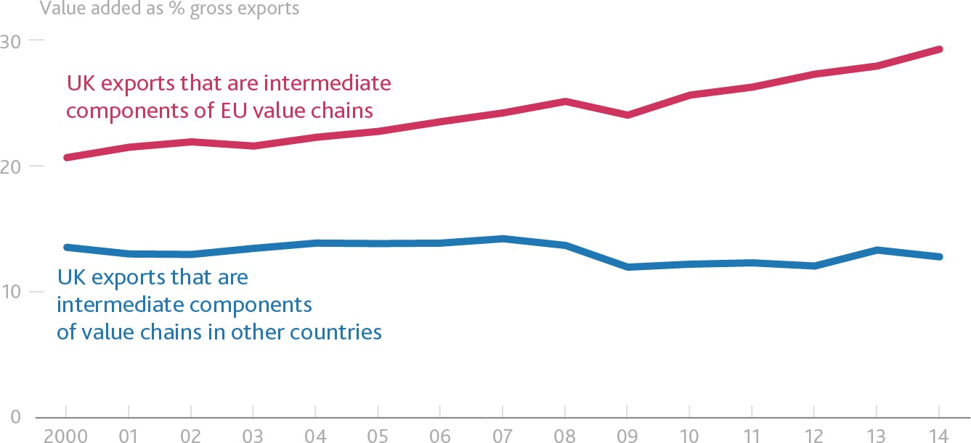

Notes: The chart shows how much of the value added by the UK in exports to the EU / other countries that is subsequently re-exported. Sources: Credit Suisse and World Input-Output Database (2016 release).

Retaining some of these positions may be challenging as evidence indicates that trade in intermediates appears to be more sensitive to trade costs such as tariffs. Given that proximity also appears to be more important for trade in intermediates than for trade in final goods,48 international substitutes for European buyers of UK intermediates, as well as European suppliers of intermediates into UK supply chains, may be more difficult to source.

These effects and the experience of the past 30 years prompt the question: if globalisation is disinflationary, won’t Brexit be inflationary?

Certainly, this process of de-integration can be expected to steepen the Phillips Curve given disruptions to in-bound value chains from Europe and reduced contestability of UK labour and product markets. In addition, the reallocation of capital to suit new trade arrangements will take time, weighing on growth of the economy’s supply capacity while it proceeds. Moreover, any increase in tariffs on UK imports, or increases in the cost of imports due to broader access restrictions, would cause the Phillips Curve to shift up temporarily as those higher costs are passed through the supply chain.

These inflationary effects may be reinforced by developments in the labour market. As in other advanced economies, the expansion in global labour supply has forced a painful period of adjustment for the most

47 The share of UK intermediate exports to the EU for which the final product remains in the EU has fallen by 6% since 1995.

48 Both these findings are reported in Miroudot, S, Lanz, R and Ragoussis, A (2009), ‘Trade in intermediate goods and services’, *OECD Trade Policy Papers*, No. 93.

exposed workers in the UK (who are not always the lowest skilled) (Chart 14).49 This reduces inflationary pressures in the economy as a whole.

# Chart 14: Relative wages of workers exposed to global labour markets squeezed

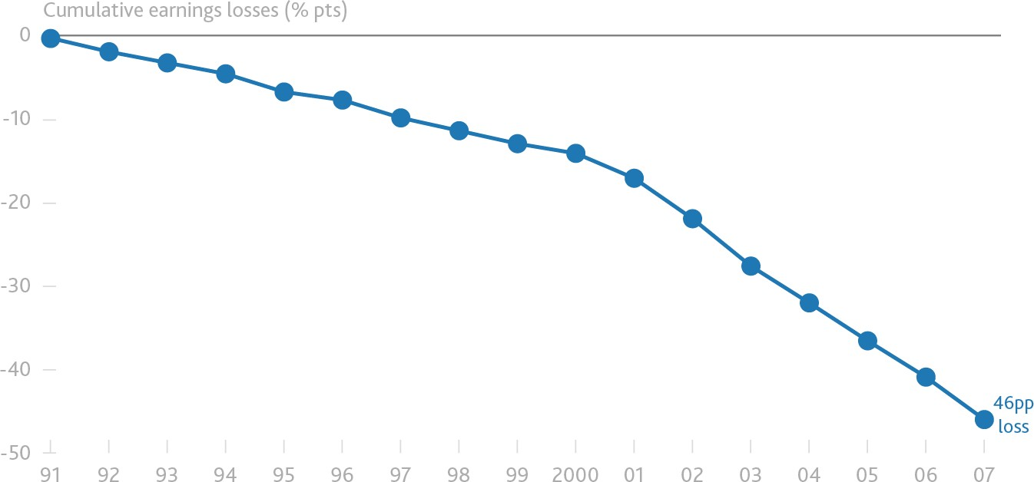

Notes: The chart shows the estimated loss in earnings since 1991 for a worker at a company in the manufacturing sector with a high exposure to rising competition relative to a worker with a low exposure, expressed as a share of their annual earnings in 1991.

Source: Professor David Autor, ‘Economic and political consequences of China’s rise for the United States: lessons from the China Shock’, IFS Annual Lecture 2017, 22 June 2017.

Higher levels of migration in the UK have not, however, been associated with significant reductions in overall wage growth and therefore inflation.50 Bank research suggests a 10% increase in labour supply (equivalent to a rise of around 265,000 in net migration) typically reduces inflation by only around 0.1 percentage points.51 This is because the effects of changes in migration on the supply of labour are largely balanced by corresponding changes in demand.

This means that any reduction in net migration after Brexit could therefore ultimately have only a modest impact on prices in general equilibrium. Over a shorter horizon, however, abrupt decreases in migration could result in shortages in some sectors that have become reliant on migrant labour, and contribute more materially to inflationary pressures.

In addition, the ease with which UK employers have been able to source labour from abroad and move operations offshore as a result of globalisation may have weighed on wage growth – though the size of such contestability effects is difficult to judge. To the extent that such effects have operated, any restrictions on labour that result from Brexit – both effective and actual – should steepen the wage Phillips curve, increasing

49 Pessoa, J (2016), ‘International competition and labour market adjustment’, CEPR Discussion Paper No. 1411. Bank research replicating the work of Autor *et al*, ibid, finds that areas in the UK with a high exposure to Chinese competition have experienced large falls in manufacturing employment, with offsetting rises in non-manufacturing employment.

50 The largest effects are for lower-skilled workers in services industries. See Nickell, S and Saleheen, J (2015), ‘The impact of immigration on occupational wages: evidence from Britain’, Bank of England Staff Working Paper No. 574.

51 See the box on pages 30-31 May 2015 *Inflation Report.*

the sensitivity of domestic wages to domestic labour market slack (moving in the opposite direction to the rotation shown by (3) in Figure 1 above).

UK potential supply capacity itself is also likely to be lower as some capacity tied to Europe becomes obsolete. The reduction and reorientation of trade is likely to weigh on productivity for some time through a loss of comparative advantage and the disruption of supply chains as companies in the UK shift from supplying customers in the EU to customers in the rest of the world. Empirical estimates suggest a 20% reduction in trade tends to drag on productivity by around 5% in the long run.52 The actual impact will depend on how quickly any lost access to European and third country markets (via European trade deals) can be replaced. In this regard, the UK Prime Minister’s discussions in Canada today are potentially significant.

With respect to the exchange rate, the effects of imported inflation are particularly important to UK inflation dynamics, given both the openness of its economy, the low degree of home currency invoicing53 and the relatively slow but significant pass through of large, persistent exchange rate moves.

Around 60% of persistent movements in sterling tend to be passed through into import prices and those changes in import prices are fully – if gradually – passed through into consumer prices. The total import content of final consumer goods and services is close to 30%, of which around half is due to the use of imported intermediates in production. A 10% change in the exchange rate would therefore be expected to increase import prices by 6% and the level of consumer prices by 1.6% eventually. About half of the increase in import prices is passed through within the first year, with full pass-through taking around four years to complete.

In other words, in the UK, large exchange rate moves create price dynamics that are relevant to the policy horizon.54

Post Brexit, sterling will reflect changes in the UK’s terms of trade, supply capacity and relative income. The market has already anticipated some of these effects. Whether it ultimately appreciates or depreciates upon Brexit will depend on the terms of the final deal relative to market expectations at the time.

Turning finally to the policy implications, it is critical to recognise that Brexit represents a real shock about which monetary policy can do little. Monetary policy cannot prevent the weaker real incomes likely to

52 See Feyrer (2009), ‘Trade and Income -- Exploiting Time Series in Geography’, NBER Working Paper No. 14910.

53 See Gopinath, G (2016), ‘The International Price System,’ Jackson Hole Symposium Proceedings. Gopinath finds that international prices measured in the currency of invoicing are not very sensitive to changes in exchange rates. So if a large share of a country’s imports is invoiced in a foreign currency, changes in its exchange rate will mostly show up in changes in the domestic currency price of imports – in other words, pass-through will be higher. For the UK, Gopinath finds that just under half of imports are invoiced in US dollars.

54 There is evidence of threshold effects in exchange rate pass-through. Pass-through of bilateral exchange rate movements that are larger than 5% is around four times larger than that of changes smaller than 5%. See Lewis, J (2016), ‘What can Big Data tell us about the pass-through of big exchange rate changes?’, Bank of England Staff Working Paper No. 579.

accompany the move to new trading arrangements with the EU, but it can influence how this hit to incomes is distributed between job losses and price rises. And it can support UK households and businesses as they adjust to such profound change.

On balance, the de-integration effects of Brexit can be expected to steepen the Phillips Curve and to be inflationary. At present, the main question concerns the extent to which this adjustment has been brought forward.

Such timing issues are one reason why the MPC has consistently stressed that the implications of Brexit for monetary policy would not be automatic. The inflation outlook will balance the inflationary effects of the exchange rate, imported inflation due to higher tariffs and a steeper Phillips curve from supply chain and labour market impacts, with the disinflationary impacts of reduced EU demand for UK goods and services, adverse effects on spending, including business investment, from the anticipation of lower growth,55 and any effects of uncertainty on domestic demand. The timing and scale of all these effects is of course subject to tremendous uncertainty.

The MPC’s remit specifies that, in exceptional circumstances such as Brexit, the Committee must balance any trade-off between the speed at which it intends to return inflation sustainably to the target and the support that monetary policy provides to jobs and activity.

That is why immediately following the referendum the Bank of England announced a series of monetary and financial measures to support the economy. These measures were calibrated to balance the trade-off that emerged immediately after the referendum between ensuring a sustainable return of inflation to target and supporting jobs and growth (Chart 15).

This stimulus is working. Credit is widely available, the cost of borrowing is near record lows, the economy has outperformed expectations, and unemployment has reached a 42 year low. As a consequence, the trade-off between inflation and spare capacity is diminishing.

55 Blanchard, O, Cerutti, E and Summers, L (2015), ibid.

# Chart 15: Trade-off that emerged after the referendum has diminished

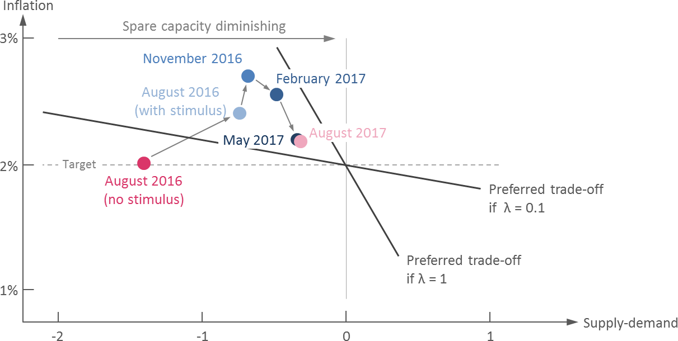

UK households, businesses and financial markets have reacted at different speeds and to varying degrees to the prospects for the UK’s departure from the EU. In general, some of the disinflationary shock to demand has been deferred, not least because the UK has not yet left the EU, while most of the inflationary channels have begun to appear.

Financial markets, particularly sterling, marked down the UK’s relative prospects quickly and sharply. The sterling ERI has depreciated by around 20% since the Brexit process became a possibility. UK focused equities have underperformed global advanced economy equities by around 30pp since the Referendum (in common currency terms) and UK long-run real yields are down by 60bp compared to those for the US.

Households looked through Brexit-related uncertainties initially. But more recently, as the consequences of sterling’s fall have shown up in the shops and squeezed their real incomes, they have cut back on spending, slowing the economy.

Businesses have been somewhere in between. Since the referendum, they have invested much less aggressively than usual in response to an otherwise very favourable environment (strong external environment, low cost of capital, favourable rates of profitability and limited spare capacity).

The balance of these effects has lead overall UK growth to slow in the first half of 2017, even as growth in the rest of the G7 was picking up, and UK growth looks set to remain weaker than the G7 average until mid- 2018. The UK has experienced underperformance only twice in the past three decades: once in the depths of the financial crisis and once following the collapse of the Lawson Boom of the late 1980s.

On the supply side, the process of leaving the EU is beginning to be felt. Brexit-related uncertainties are causing some companies to delay decisions about building capacity and entering new markets. Prolonged low investment will restrain growth in the capital stock and increases in productivity. Indeed, if the MPC’s current forecast comes to pass, the level of investment in 2020 is expected to be 20% below the level which the MPC had projected just before the referendum. Net migration has also fallen by 25% since the Referendum.

As a result of these factors and the general weakness in UK productivity growth since the global financial crisis, the supply capacity of the UK economy is likely to expand at only modest rates in coming years.

The latest indicators are consistent with UK demand growing a little in excess of the diminished rate of potential supply growth, and the continued erosion of what is now a fairly limited degree of spare capacity. If anything, recent developments suggest that the remaining spare capacity in the economy is being absorbed a little more rapidly than had been expected, and that inflation remains likely to overshoot the 2% target over the next three years.

The MPC’s reaction function is clear. The continued erosion of slack lessens the trade-off that the MPC is required to balance and, all else equal, reduces the MPC’s tolerance of above-target inflation.

As the Committee stated last week, if the economy continues to follow a path consistent with the prospect of a continued erosion of slack and a gradual rise in underlying inflationary pressure then, with the further lessening in the trade-off that this would imply, some withdrawal of monetary stimulus is likely to be appropriate over the coming months in order to return inflation sustainably to target.

The case for a modest monetary tightening is reinforced by the possibility that global r* may be rising, meaning that monetary policy has to move in order to stand still.

Any prospective increases in Bank Rate would be expected to be at a gradual pace and to a limited extent, and to be consistent with monetary policy continuing to provide substantial support to the economy.

There remain considerable risks to the UK outlook, which include the response of households, businesses and financial markets to developments related to the process of EU withdrawal. The MPC will respond to these developments as they occur insofar as they affect the behaviour of households and businesses, and the outlook for inflation.

# Conclusion

Before the great wave of globalisation, a series of major institutional reforms increased the transparency and accountability of central banks. The enhanced monetary policy credibility that this brought resulted in a marked drop in inflation and sizable reduction in the sensitivity of inflation to changes in slack. By driving greater competition, increased globalisation has reinforced the effectiveness of these reforms.56

Monetary policy makers, including the MPC, drew on this credibility during the financial crisis, keeping inflation expectations anchored in the face of deflationary pressures from both home and abroad.

Regardless of how external influences on inflation evolve in future, the institutional framework of the Bank of England, which is currently celebrating its 20th anniversary of independent monetary policy, leaves the MPC well equipped to deliver price stability.

The biggest determinants of the UK’s medium-term prosperity will be the country’s new relationship with the EU and the reforms that it catalyses. Many of the adjustments needed to move to that new equilibrium are real in nature, and are not in the gift of monetary policymakers. But monetary policy can help build the foundations for lasting prosperity by achieving the inflation target in a way that helps smooth real adjustment in the economy and supports jobs in the wake of very large external forces. This is the best contribution the MPC can make to the good of the people of the United Kingdom.

56 A point made by Ken Rogoff; see ‘Globalization and global disinflation’, Economic Review, Federal Reserve Bank of Kansas City, Issue Q IV, pages 45-78. In technical terms, Rogoff uses the Barro-Gordon inflationary bias framework to show that the increased competition that results from greater global integration reduces the central bank’s incentive to generate surprise inflation by: (i) reducing the wedge between the “efficient” level of output – that which would be produced if there were no nominal or real frictions in the economy – and the “natural” level of output – that which would be produced if there were only no nominal frictions – through reduced monopoly power in both the product and labour markets); and (ii) increasing price flexibility. Arguably, the increases in central bank transparency and accountability that have occurred over the past couple of decades have reinforced this decline in inflation bias.